HANOI UNIVERSITY OF SCIENCE AND TECHNOLOGY

SCHOOL OF INTERNATIONAL EDUCATION

──────── * ───────

**REPORT**

*SUBJECT*: PROJECT 2

**GROUP P2_16**

Students : **Nguyễn Cao Thùy Trang - 20138458**

**Nguyễn Lệ Hằng - 20138134**

**Đặng Vũ Đức - 20138674**

**Hoàng Thọ Dũng - 20118996**

Class : **LTU12A – K58**

Teaching guide : **Dr. Vũ Thị Hương Giang**

**Ms. Bành Thị Quỳnh Mai**

***Hanoi, month 5 year 2017***

Table of Content

Table of Content 2

INTRODUCTION 4

CONTRIBUTION OF MEMBERS 5

CHAPTER 1. SYSTEM ANALYSIS, REQUIREMENT ANALYSIS AND APPROACH/SOLUTION DESIGN 6

1.1. Description of requirement 7

1.2. Functional Analysis 8

1.2.1. Actor 8

1.2.2. Use case 9

1.3. Database Design 22

1.3.1. Input/output Data 22

1.3.2. Database 23

1.4. Algorithm Design 23

1.5. Interface Design 24

1.5.1. Sitemap 24

1.5.2. Wireframe 25

1.5.3. Site flow 31

1.5.4. Interaction support 9

CHAPTER 2. IMPLEMENTATION AND SYSTEM TEST 36

1.6. Programming Platform 36

1.6.1. Programming Language 36

1.6.2. IDE / Programming Framework 36

1.6.3. Libraries 36

1.7. Results 35

CONCLUSION AND FUTURE WORK 37

REFERENCE 38

INTRODUCTION

*Currently, the management of internship issues in schools is very necessary. The computerization of the internship management system contributes significantly to the handling and storage of information.*

*Through study and research, we have decided together to analyze and design the internship management website for SIE. The information on the continual change of practice makes adding, deleting, updating complicated and lack of mobility if not digitized. That is why we chose this topic.*

*To accomplish this project, our team would like to sincerely thank:*

*The instructors - Dr. Vu Thi Huong Giang, Master Banh Thi Quynh Mai has all the help, guidance, instruction dedicated to the group to complete this project.*

*LTU-12A students gave their enthusiastic comments and suggestions during the course of the project*

*Hanoi, month 5 year 2017*

*P2_16 – LTU12A:*

1. *Nguyễn Cao Thùy Trang.*
2. *Đặng Vũ Đức.*
3. *Nguyễn Lệ Hằng.*
4. *Hoàng Thọ Dũng.*

CONTRIBUTION OF MEMBERS

|  |  |  |  |  |  |  |
| --- | --- | --- | --- | --- | --- | --- |
| Name | Student ID | Tasks assigned | Tasks contributed | Time completed | % contribution | Level of completion |
| Nguyễn Cao Thùy Trang | 20138458 | Give jobs to members | Give jobs to members | 1 day | 40% | 100% |
| Design use case diagram for User, Student, Admin and describe specification | Design use case diagram for User, Student, Admin and describe specification | 2 days | 100% |
| Làm thay Đức phần Design Database | Design and build database of all actors | 5 days | 100% |
| Sketch and edit the whole interfaces | Sketch and edit the whole interfaces | 3 days | 100% |
| Connect interface with source code | Connect interface with source code | 3 days | 100% |
| Làm thay Đức phần Edit Profile | Code Edit profile for all users | 1 days | 100% |
| Code module manage mark | Code module manage mark | 1 day | 90% |
| Làm thay Dũng module timesheet | Code module timesheet | 1 day | 90% |
| Làm thay Dũng module statistic | Code module statistic | 1 day | 90% |
| Làm thay Dũng module manage users, authorize | Code module manage users, authorize | 1 day | 90% |
| Fix bugs of interfaces when needed | Fix bugs of interfaces when needed | 2 days | 80% |
| Fix bugs, optimized code | Fix bugs, optimized code | 2 days | 80% |
| 1st testing | 1st testing | 1 day | 100% |
| Nguyễn Lệ Hằng | 20138134 | Write the outline, group’s report, testing report | Write the outline, group’s report, testing report | 2 days | 35% | 100% |
| Design Use case diagram for other actors and describe specification | Design Use case diagram for other actors and describe specification, | 2 days | 100% |
| Design the whole interface | Design the whole interface | 14 days | 100% |
| Làm thay Dũng module Login - Logout | Code Login, Logout function | 1 day | 90% |
| Code module censor topic | Code module censor topic | 1 day | 90% |
| Code module auto-match | Code module auto-match | 2 days | 90% |
| Làm thay Dũng module assignment | Code module assignment | 1 day | 90% |
| Deploy with Đức | Deploy server | 1 day | 100% |
| Finding bugs, Testing website | Finding bugs, Testing website | 2 days | 80% |
| 2nd testing | 2nd testing | 1 day | 100% |
| Đặng Vũ Đức | 20138674 | Design and build database of all actors | Không làm. Chuyển cho Trang. | 0 | 25% | 0 |
| Làm thay Dũng phần Exceptions | Describe Exceptions | 1 day | 90% |
| Làm thay Dũng phần Connections between Actors | Describe Connections between Actors | 1 day | 90% |
| Code Edit profile for all users | Không làm đúng thời hạn. Chuyển sang cho Trang | 0 | 0 |
| Code Publish topic function | Code Publish topic function | 1 day | 80% |
| Code View topic function | Code View topic function | 1 day | 80% |
| Code Module Mark for College and Company Instructor | Code Module Mark for College and Company Instructor | 2 days | 80% |
| Deploy server with Hằng | Deploy server | 1 day | 100% |
| Insert example data | Insert example data | 1 hour | 100% |
| Hoàng Thọ Dũng | 20118996 | Describe Exceptions | Không làm. Chuyển cho Đức. | 0 | 0% | 0 |
| Describe Connections between Actors | Không làm. Chuyển cho Đức. | 0 | 0 |
| Code module timesheet | Không làm. Chuyển cho Trang | 0 | 0 |
| Code module statistic | Không làm. Chuyển cho Trang | 0 | 0 |
| Code module manage users, authorize | Không làm. Chuyển cho Trang | 0 | 0 |
| Code Login, Logout function | Không làm. Chuyển cho Hằng. | 0 | 0 |
| Code module assignment | Không làm. Chuyển cho Hằng. | 0 | 0 |

# CHAPTER 1. SYSTEM ANALYSIS, REQUIREMENT ANALYSIS AND APPROACH/SOLUTION DESIGN

## Description of requirement

|  |  |
| --- | --- |
| **Origin Requirement** | **Requirement developed by students** |
| The product must be a website that deploy in a webserver or cloud server, not use local host | A website that deploy in cloud server |
| **Students:**   * Add / Edit Curriculum Vitae * See lists of internship topics * Fill out the registration form of intern aspiration * Feedback on the intern state * Submit the reports * View the review of the internship * View the internship point | **Students:**   * Edit profile * Add / Edit CV * Fill out the registration form of intern aspiration * See lists of internship topics * Submit the reports * View the intern’s status * View the intern’s point * Feedback on the intern’s status |
| **Company representative:**   * Fill out the registration form to receive internships | **Company representative:**   * Publish topic list * Fill out the registration form to receive internships |
| **Company instructor:**   * Submiss the detailed outline * Score according to form * Comments/ feedback according to form | **Company instructor:**   * Submiss the detailed outline * Fill out mark’s form * Comments/ feedback according to form * Submit timesheet |
| **College internship manager:**   * Matching information with aspirations/ destination * Making decisions internship assignment in batches * Statisticing the status of student’s internship finished/unfinished | **College internship manager:**   * Topic’s censor * Assign schedule * Statisticing the status of student’s internship finished/ unfinished |
| **College instructor:**   * Score the internship * Exchange to the instructor at the enterprise | **College instructor:**   * Marking and evaluating the results of the internship |
| **Admin:**   * Manage users: * Note: students use school’s email, business regists email with domain name registration of enterprises * Can be use facebook login. * Manage score * Automatic configuration: * Automatically remind instructor to score, give feedback (email, SMS, FB account …) * Parameter match the aspiration of students and the destination. | **Admin:**   * Manage users: * Create accounts for user * Manage mark: Ability to view and edit internships * Automatic configuration |

## Functional Analysis

### Actor

7 actors:

* User
* Student
* College internship manager
* College instructor
* Company representative
* Company instructor
* Admin

### Use case

#### *General UseCase Diagram:*

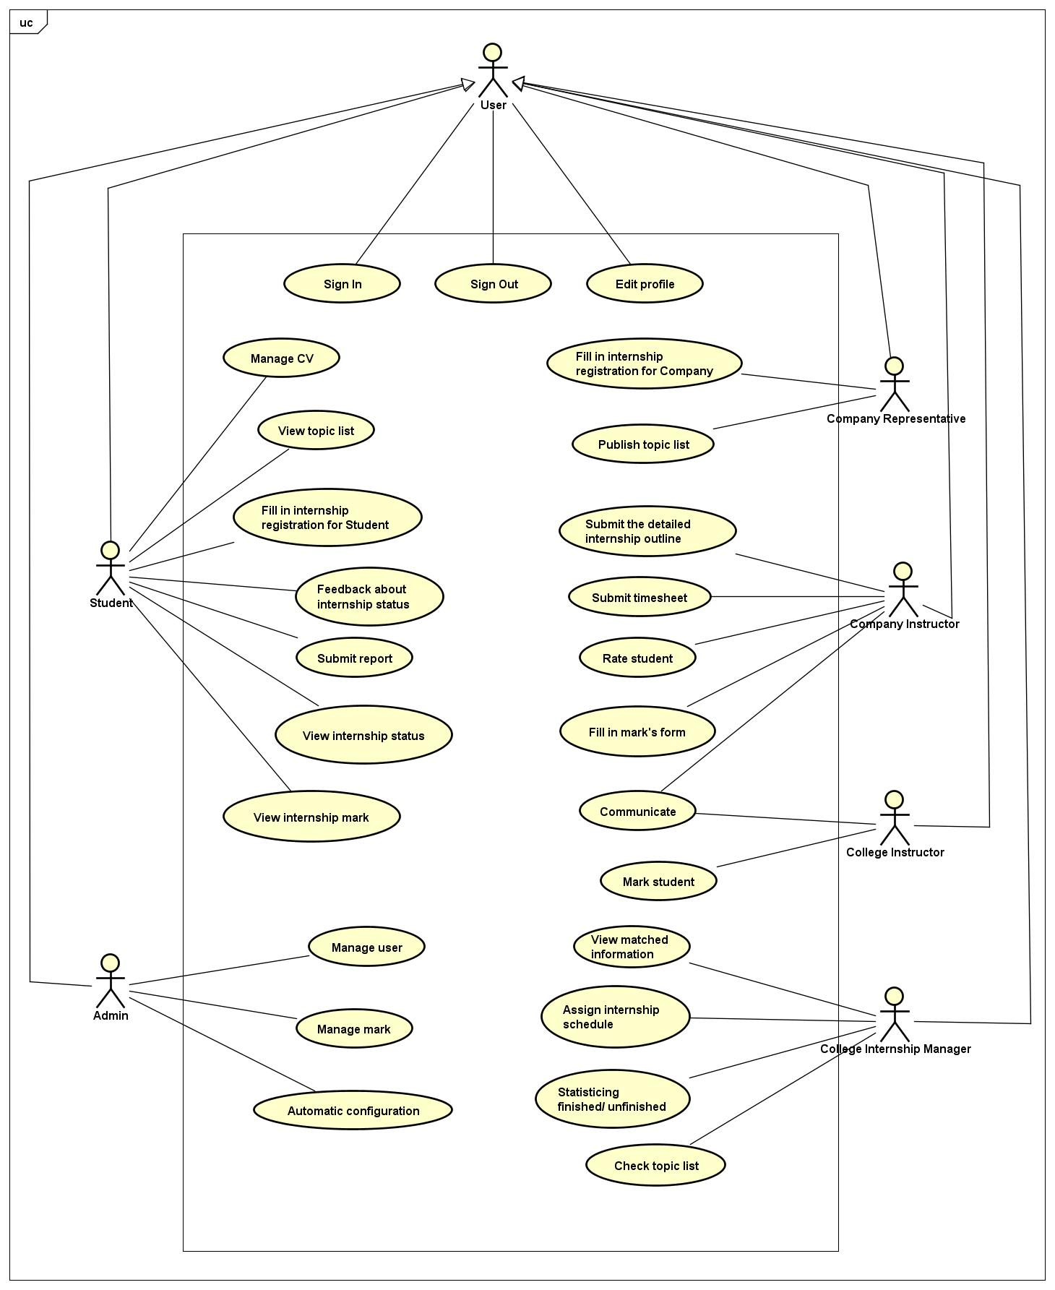

#### *Level 2 Usecase Diagram:*

* Student - Manage CV: 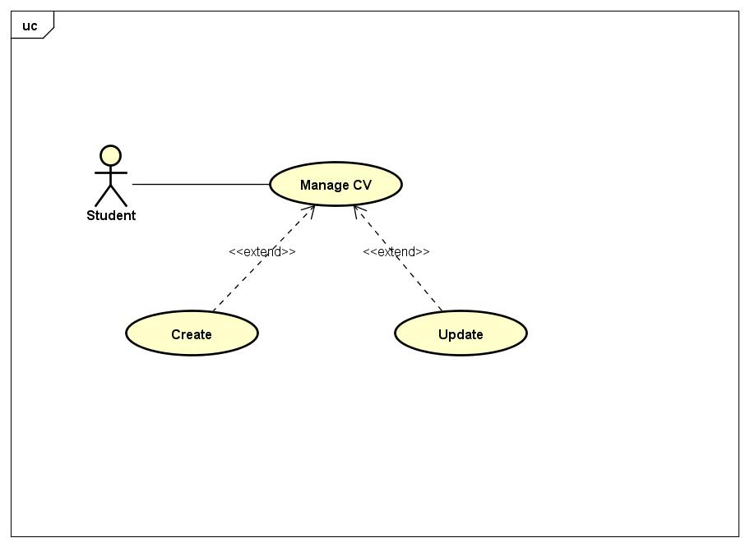
* Student – Submit Report:

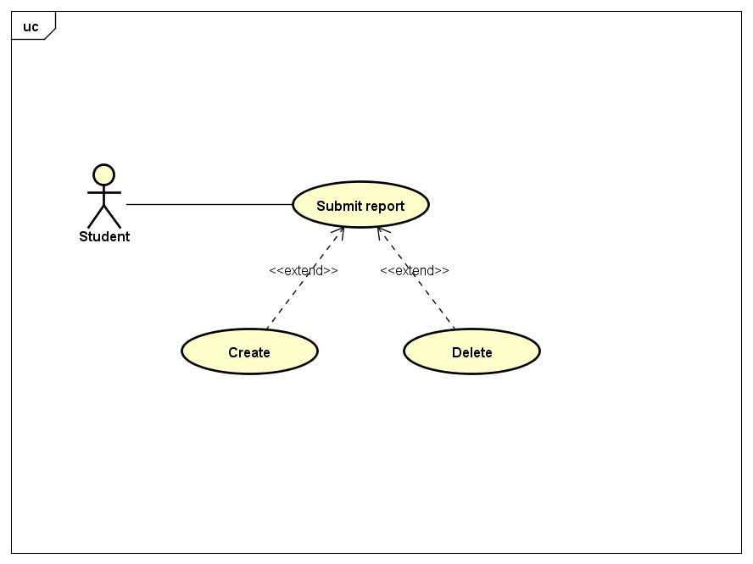

* Company Instructor - Submit the detailed internship outline:

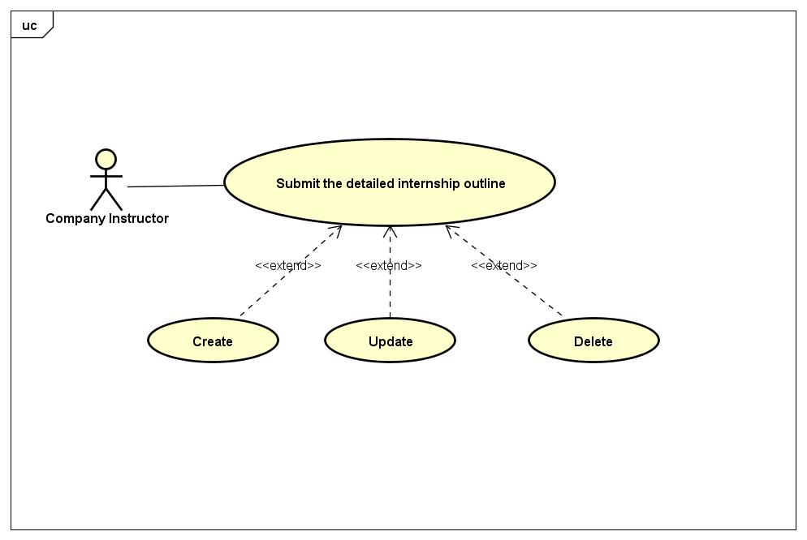

#### *Usecase specification:*

**Sign In (UC1):**

|  |  |  |
| --- | --- | --- |
| *Use Case* | Sign In | |
| *Actor* | User | |
| *Brief Description* | Allow user to sign in with an existed account | |
| *Main events* | *Activities of actor* | *System react* |
| Fill UserID and Password, then click Sign in. |  |
|  | Send the input information to database and check. |
|  | Display the successful login window. |
| *Alternative events* | 3.1. If the account information is incorrect, ask user to enter the information again (limited times). | |
| *Precondition* | None | |
| *Post condition* | None | |

**Sign Out (UC2):**

|  |  |  |
| --- | --- | --- |
| *Use Case* | Sign Out | |
| *Actor* | User | |
| *Brief Description* | Allow user to sign out. | |
| *Main events* | *Activities of actor* | *System react* |
| Click Sign Out. |  |
|  | Sign out from the system, display Sign in GUI. |
| *Alternative events* |  | |
| *Precondition* | None | |
| *Post condition* | None | |

**Edit Profile (UC3):**

|  |  |  |
| --- | --- | --- |
| *Use Case* | Edit profile | |
| *Actor* | User | |
| *Brief Description* | Allow user to edit his / her own profile | |
| *Main events* | *Activities of actor* | *System react* |
| Opens his / her own Profile, click Edit. |  |
|  | Displays ProfileGUI and allows User to edit |
| Edit Profile, click Save. |  |
|  | Update new information. |
| *Alternative events* |  | |
| *Precondition* | User must be signed in to the system. | |
| *Post condition* | None | |

**Manage CV (UC4):**

|  |  |  |
| --- | --- | --- |
| *Use Case* | Manage CV | |
| *Actor* | Student | |
| *Brief Description* | Allow user to create and update his / her own CV | |
| *Main events* | *Activities of actor* | *System react* |
| Click CV. |  |
|  | Displays CV form. |
| Fills all necessary information and click Save. |  |
|  | Checks input information and notifies user of the success CV. |
| *Alternative events* | 4a. Wrong or missing information, notifies user.  5. User fills information again, click Save | |
| *Precondition* | User must be signed in to the system. | |
| *Post condition* | None | |

**View topic lists (UC5):**

|  |  |  |
| --- | --- | --- |
| *Use Case* | View topic lists | |
| *Actor* | Student | |
| *Brief Description* | Allow user to choose internship speciality | |
| *Main events* | *Activities of actor* | *System react* |
| Click Topic. |  |
|  | Displays speciality list. |
| Choose the speciality and checkpoint, then Submit. |  |
|  | Checks input information to match. |
| *Alternative events* | None | |
| *Precondition* | User must be signed in to the system. | |
| *Post condition* | None | |

**Fill in internship registration for Student (UC6):**

|  |  |  |
| --- | --- | --- |
| *Use Case* | Fill in internship registration for Student | |
| *Actor* | Student | |
| *Brief Description* | Allow user to register intern | |
| *Main events* | *Activities of actor* | *System react* |
| Click Registration. |  |
|  | Displays Registration form. |
| Fills all necessary information and click Submit. |  |
|  | Checks input information and notifies user of the success registration. |
| *Alternative events* | 4a. Wrong or missing information, notifies user.  5. User fills information again, click Save | |
| *Precondition* | User must be signed in to the system. | |
| *Post condition* | None | |

**Feedback about internship status (UC7):**

|  |  |  |
| --- | --- | --- |
| *Use Case* | Feedback about internship status | |
| *Actor* | Student | |
| *Brief Description* | Allow user to feedback about internship status | |
| *Main events* | *Activities of actor* | *System react* |
| Click Feedback. |  |
|  | Displays Feedback GUI. |
| Feedback and click Submit. |  |
|  | Checks input information and notifies user of the succeed. |
| *Alternative events* | None | |
| *Precondition* | User must be signed in to the system. | |
| *Post condition* | None | |

**Submit report (UC8):**

|  |  |  |
| --- | --- | --- |
| *Use Case* | Submit report | |
| *Actor* | Student | |
| *Brief Description* | Allow user to submit report | |
| *Main events* | *Activities of actor* | *System react* |
| Click Report. |  |
|  | Displays Report GUI. |
| Upload file. |  |
|  | Checks input and notifies user of the succeed. |
| *Alternative events* | None. | |
| *Precondition* | User must be signed in to the system. | |
| *Post condition* | None | |

**View internship status (UC9):**

|  |  |  |
| --- | --- | --- |
| *Use Case* | View internship status | |
| *Actor* | Student | |
| *Brief Description* | Allow user to view internship status | |
| *Main events* | *Activities of actor* | *System react* |
| Click Status. |  |
|  | Displays Status GUI. |
| *Alternative events* | None. | |
| *Precondition* | User must be signed in to the system. | |
| *Post condition* | None | |

**View internship mark (UC10):**

|  |  |  |
| --- | --- | --- |
| *Use Case* | View internship mark | |
| *Actor* | Student | |
| *Brief Description* | Allow user to view internship mark | |
| *Main events* | *Activities of actor* | *System react* |
| Click Mark. |  |
|  | Displays Mark GUI. |
| *Alternative events* | None. | |
| *Precondition* | User must be signed in to the system. | |
| *Post condition* | None | |

**View matched information (UC11):**

|  |  |  |
| --- | --- | --- |
| *Use Case* | View matched information | |
| *Actor* | College Internship Manager | |
| *Brief Description* |  | |
| *Main events* | *Actor’s action* | *System’s react* |
| Click the Matched List button |  |
|  | Show the Matched List’s view |
| Check the information. If there is a mistake, click Report. If none, click Submit |  |
|  | Receive information. Return success or failure notification. |
| *Exceptions* |  | |
| *Precondition* | College Internship Manager must be logged into the system | |
| *Post condition* | Notice success or failure | |

**Assign internship schedule (UC12):**

|  |  |  |
| --- | --- | --- |
| *Use Case* | Assign internship schedule | |
| *Actor* | College Internship Manager | |
| *Brief Description* |  | |
| *Main events* | *Actor’s action* | *System’s react* |
| Click Internship Assignment button |  |
|  | Show Assignment’s GUI |
| Check the information. If unreasonable, choose another option beside |  |
| Click Submit |  |
|  | Receive information. Return success of failure notification |
| *Alternative events* |  | |
| *Precondition* | College Internship Manager must be logged into the system | |
| *Post condition* | Notice success or failure | |

**Statisticing the status of Student’s internship finished/unfinished (UC13):**

|  |  |  |
| --- | --- | --- |
| *Use Case* | Statisticing the status of Student’s internship finished / unfinished | |
| *Actor* | College Internship Manager | |
| *Brief Description* |  | |
| *Main events* | *Actor’s action* | *System’s react* |
| Click the Statistics button |  |
|  | Show the Statistics’s GUI |
| Check student’s internship finished/ unfinished |  |
|  |  | Receive information. Return success of failure notification |
| *Exceptions* |  | |
| *Precondition* | College Internship Manager must be logged into the system | |
| *Post condition* |  | |

**Check topic list (UC14):**

|  |  |  |
| --- | --- | --- |
| *Use Case* | Check topic list | |
| *Actor* | College internship manager | |
| *Brief Description* |  | |
| *Main events* | *Actor’s action* | *System’s react* |
| Click Internship assignment button |  |
|  | Show 2 options |
| Choose Topic list option |  |
|  | Show topic list’s GUI |
| Check and confirm. If ok, click Confirm button. If not, click Another Topic button |  |
| *Exceptions* |  | |
| *Precondition* | College Internship Manager must be logged into the system | |
| *Post condition* |  | |

**Communicate with Company Instructor (UC15):**

|  |  |  |
| --- | --- | --- |
| *Use Case* | Communicate with Company Instructor | |
| *Actor* | College Instructor | |
| *Brief Description* |  | |
| *Main events* | *Actor’s action* | *System’s react* |
| Click the Chat button |  |
|  | Show the Chat’s window |
| Select Company Instructor who want to contact |  |
|  | Show Company Instructor’s window chat has been chosen |
| Start communicate |  |
| *Exceptions* |  | |
| *Precondition* | College Internship Manager must be logged into the system | |
| *Post condition* |  | |

**Mark student (UC16):**

|  |  |  |
| --- | --- | --- |
| *Use Case* | Mark student | |
| *Actor* | College Instructor | |
| *Brief Description* |  | |
| *Main events* | *Actor’s action* | *System’s react* |
| Click Intern button |  |
|  | Show 1 option |
| Choose Mark option |  |
|  | Show List of student |
| Mark student |  |
| Click Submit |  |
|  | Receive information, return success or failure notification |
| *Exceptions* |  | |
| *Precondition* | College Internship Manager must be logged into the system | |
| *Post condition* |  | |

**Fill in internship registration for Company (UC17):**

|  |  |  |
| --- | --- | --- |
| *Use Case* | Fill in internship registration for Company | |
| *Actor* | Company Representative | |
| *Brief Description* |  | |
| *Main events* | *Actor’s action* | *System’s react* |
| Click the Register button |  |
|  | Show the form of register |
| Fill in the registration form to receive student internships |  |
| Click Submit button |  |
|  | Receive information, return success or failure notification |
| *Exceptions* | Company representative cancels the registration  Company representative have not filled in the necessary information yet. | |
| *Precondition* | Company representative must be logged into the system | |
| *Post condition* | Notice success or failure | |

**Publish topic list (UC18):**

|  |  |  |
| --- | --- | --- |
| *Use Case* | Publish topic list | |
| *Actor* | Company Representative | |
| *Brief Description* | Company Representative can upload the topic | |
| *Main events* | *Actor’s action* | *System’s react* |
| Click the Topic button |  |
|  | Show Topic GUI |
| Upload topic |  |
| Save form |  |
|  | Receive information, return success or failure notification |
| *Exceptions* | Company representative cancels upload | |
| *Precondition* | Company representative must be logged into the system | |
| *Post condition* | Notice success or failure | |

**Submit the deatiled internship outline (UC19):**

|  |  |  |
| --- | --- | --- |
| *Use Case* | Submit the detailed internship outline | |
| *Actor* | Company Instructor | |
| *Brief Description* | Company Instructor can upload the detailed outline | |
| *Main events* | *Actor’s action* | *System’s react* |
| Click the Intern button |  |
|  | Show 3 options of Intern |
| Choose Outline option |  |
|  | Show Outline form |
| Upload outline |  |
| Click Submit button |  |
|  | Receive information, return success or failure notification |
| *Exceptions* | Company Instructor cancels upload | |
| *Precondition* | Company Instuctor must be logged into the system | |
| *Post condition* | Notice success or failure | |

**Fill in Mark’s form (UC20):**

|  |  |  |
| --- | --- | --- |
| *Use Case* | Fill in Mark’s form | |
| *Actor* | Company Instructor | |
| *Brief Description* | Company Instructor can score by fill in mark’s form | |
| *Main events* | *Actor’s action* | *System’s react* |
| Click Intern button |  |
|  | Show 3 options |
| Choose Mark option |  |
|  | Show List of student |
| Choose student who want to score |  |
|  | Show mark’s form |
| Fill in mark’s form |  |
| Click Submit |  |
|  | Receive information, return success or failure notification |
| *Exceptions* | Company Instructor cancels | |
| *Precondition* | Company Instuctor must be logged into the system | |
| *Post condition* | Notice success or failure | |

**Rate student (UC21):**

|  |  |  |
| --- | --- | --- |
| *Use Case* | Rate student | |
| *Actor* | Company Instructor | |
| *Brief Description* |  | |
| *Main events* | *Actor’s action* | *System’s react* |
| Click Intern button |  |
|  | Show 3 options |
| Choose Rate option |  |
|  | Show the Rate’s form |
| Fill in information |  |
| Click Submit |  |
|  | Receive information, return success or failure notification |
| *Exceptions* | Company Instructor cancels | |
| *Precondition* | Company Instuctor must be logged into the system | |
| *Post condition* | Notice success or failure | |

**Submit timesheet (UC22):**

|  |  |  |
| --- | --- | --- |
| *Use Case* | Submit timesheet | |
| *Actor* | Company instructor | |
| *Brief Description* | Company instructor can upload file timesheet | |
| *Main events* | *Activities of actor* | *System react* |
| Click Intern button |  |
|  | Show 4 options |
| Choose Timesheet option |  |
|  | Show the Timesheet’s form |
| Upload Timesheet file |  |
| Click Submit |  |
|  | Receive information, return success or failure notification |
| *Alternative events* | None | |
| *Precondition* | Company Instuctor must be logged into the system | |
| *Post condition* | Notice success or failure | |

**Manage User (UC23):**

|  |  |  |
| --- | --- | --- |
| *Use Case* | Manage User | |
| *Actor* | Admin | |
| *Brief Description* | Allow admin to add, edit, delete user. | |
| *Main events* | *Activities of actor* | *System react* |
| Click User Management. |  |
| Click Add / Edit / Delete, then Save |  |
|  | Confirms Add / Edit / Delete. |
| Choose Yes. |  |
|  | Notifies of the succeed |
| *Alternative events* | 4a. Choose No, system displays User Management GUI. | |
| *Precondition* | Admin must be signed in to the system. | |
| *Post condition* | None | |

**Manage Mark (UC24):**

Automate by system.

**Automate by system (UC25):**

Automate by system

#### *Class diagram*

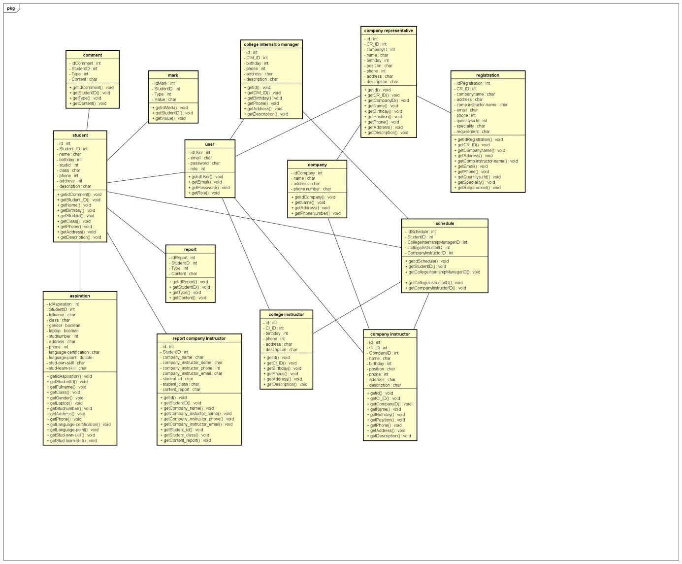

## Database Design

### Input/output Data

Input:

- List of students intern

- List of company registered

- Topic list

- Profile of students, college internship manager, college instructor, company representative, company instructor.

- Student’s CV, student’s aspirations

Output:

- List of assignments

- List of topic’s censored

- Student scores after the end of the internship

- Comments and assessments of company, instructor after internship

### Database

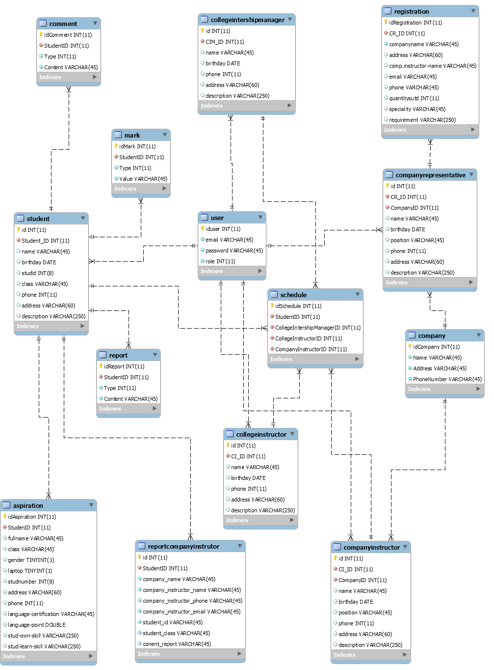

## Algorithm Design

P2_16 does not use any algorithm.

## Interface Design

### Sitemap

### Wireframe

*Login:*

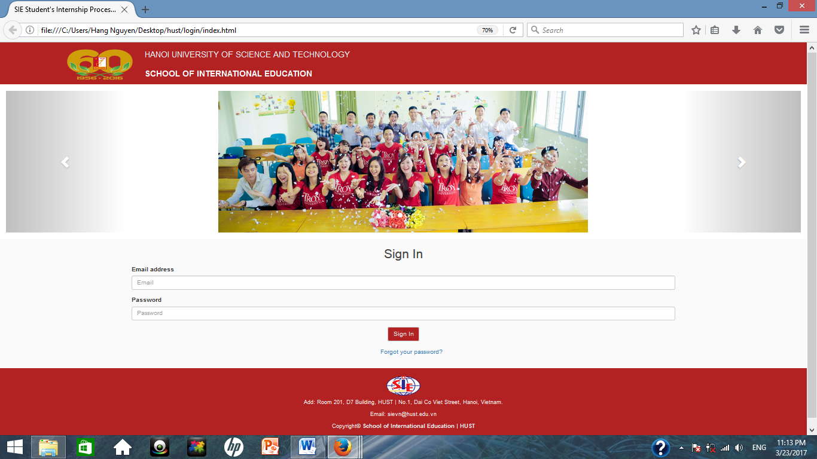

*Student:*

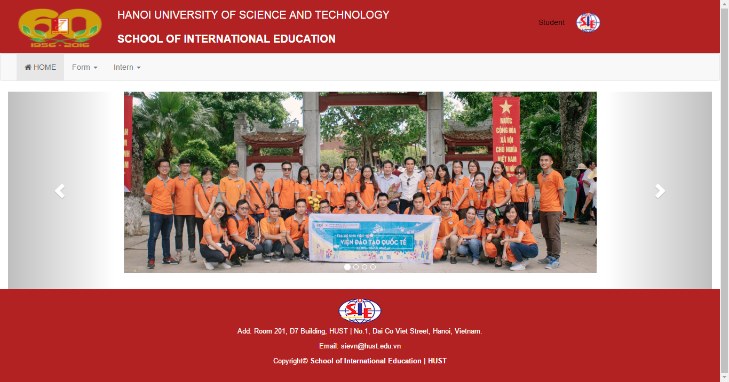

*Student – Registration’s form:*

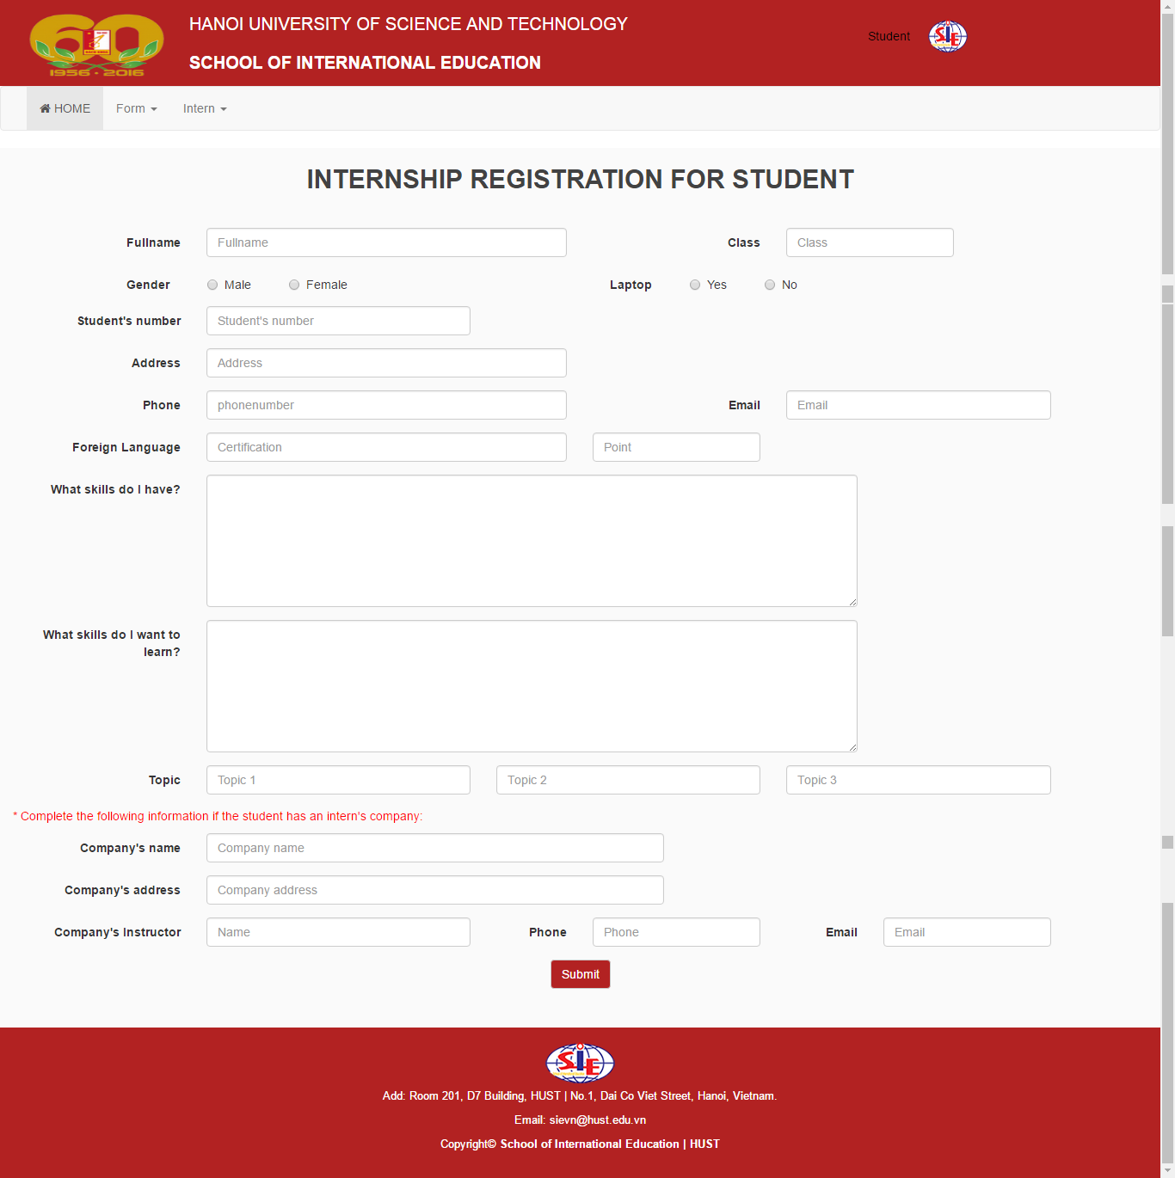

*Student – CV’s form:*

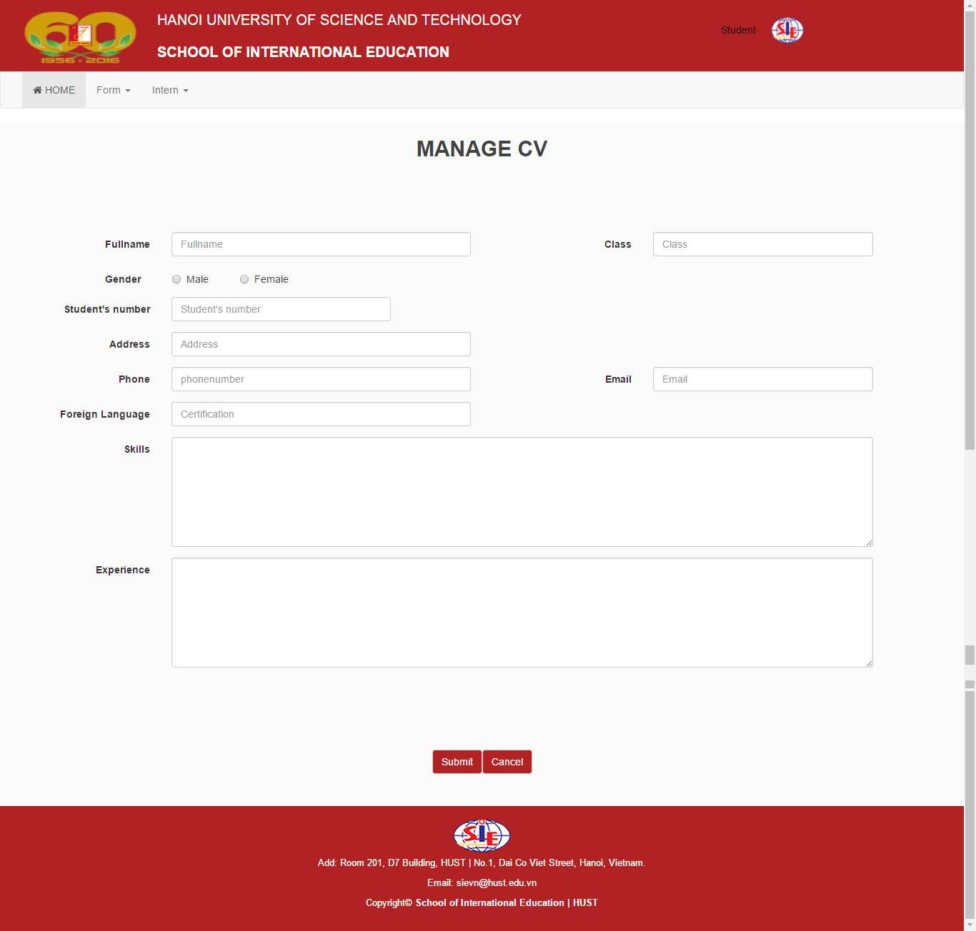

*College internship manager:*

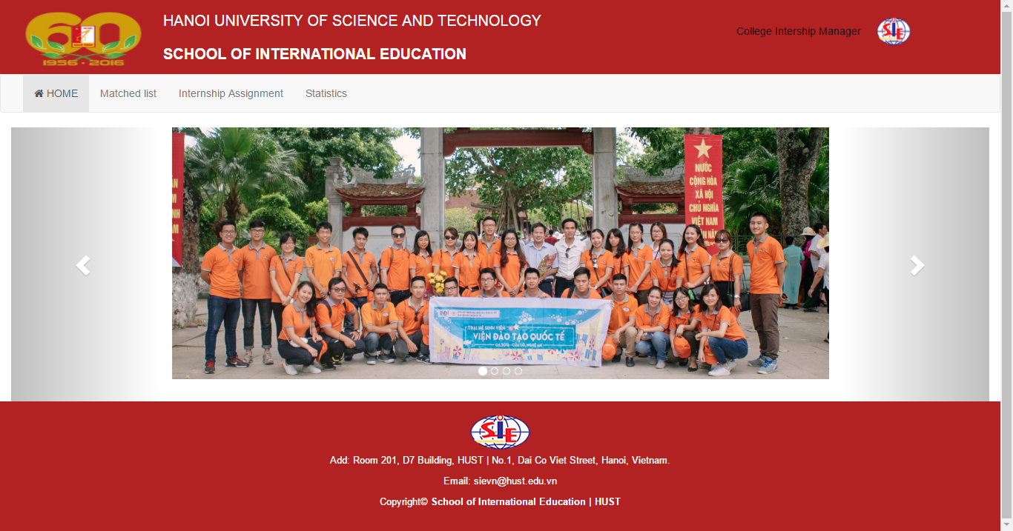

*College instructor:*



*Company representative:*



*Company instructor:*

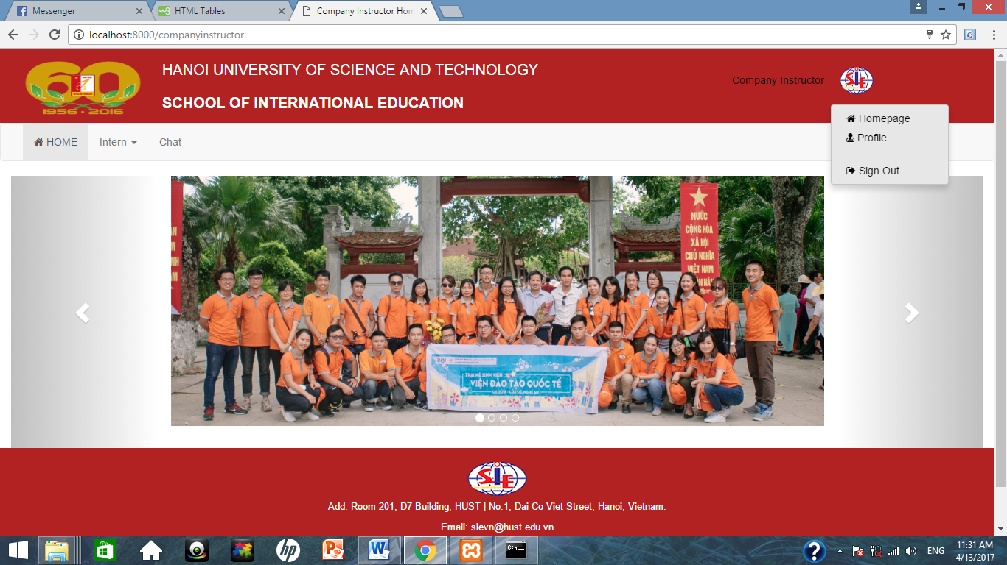

*Company instructor – Mark’s form:*

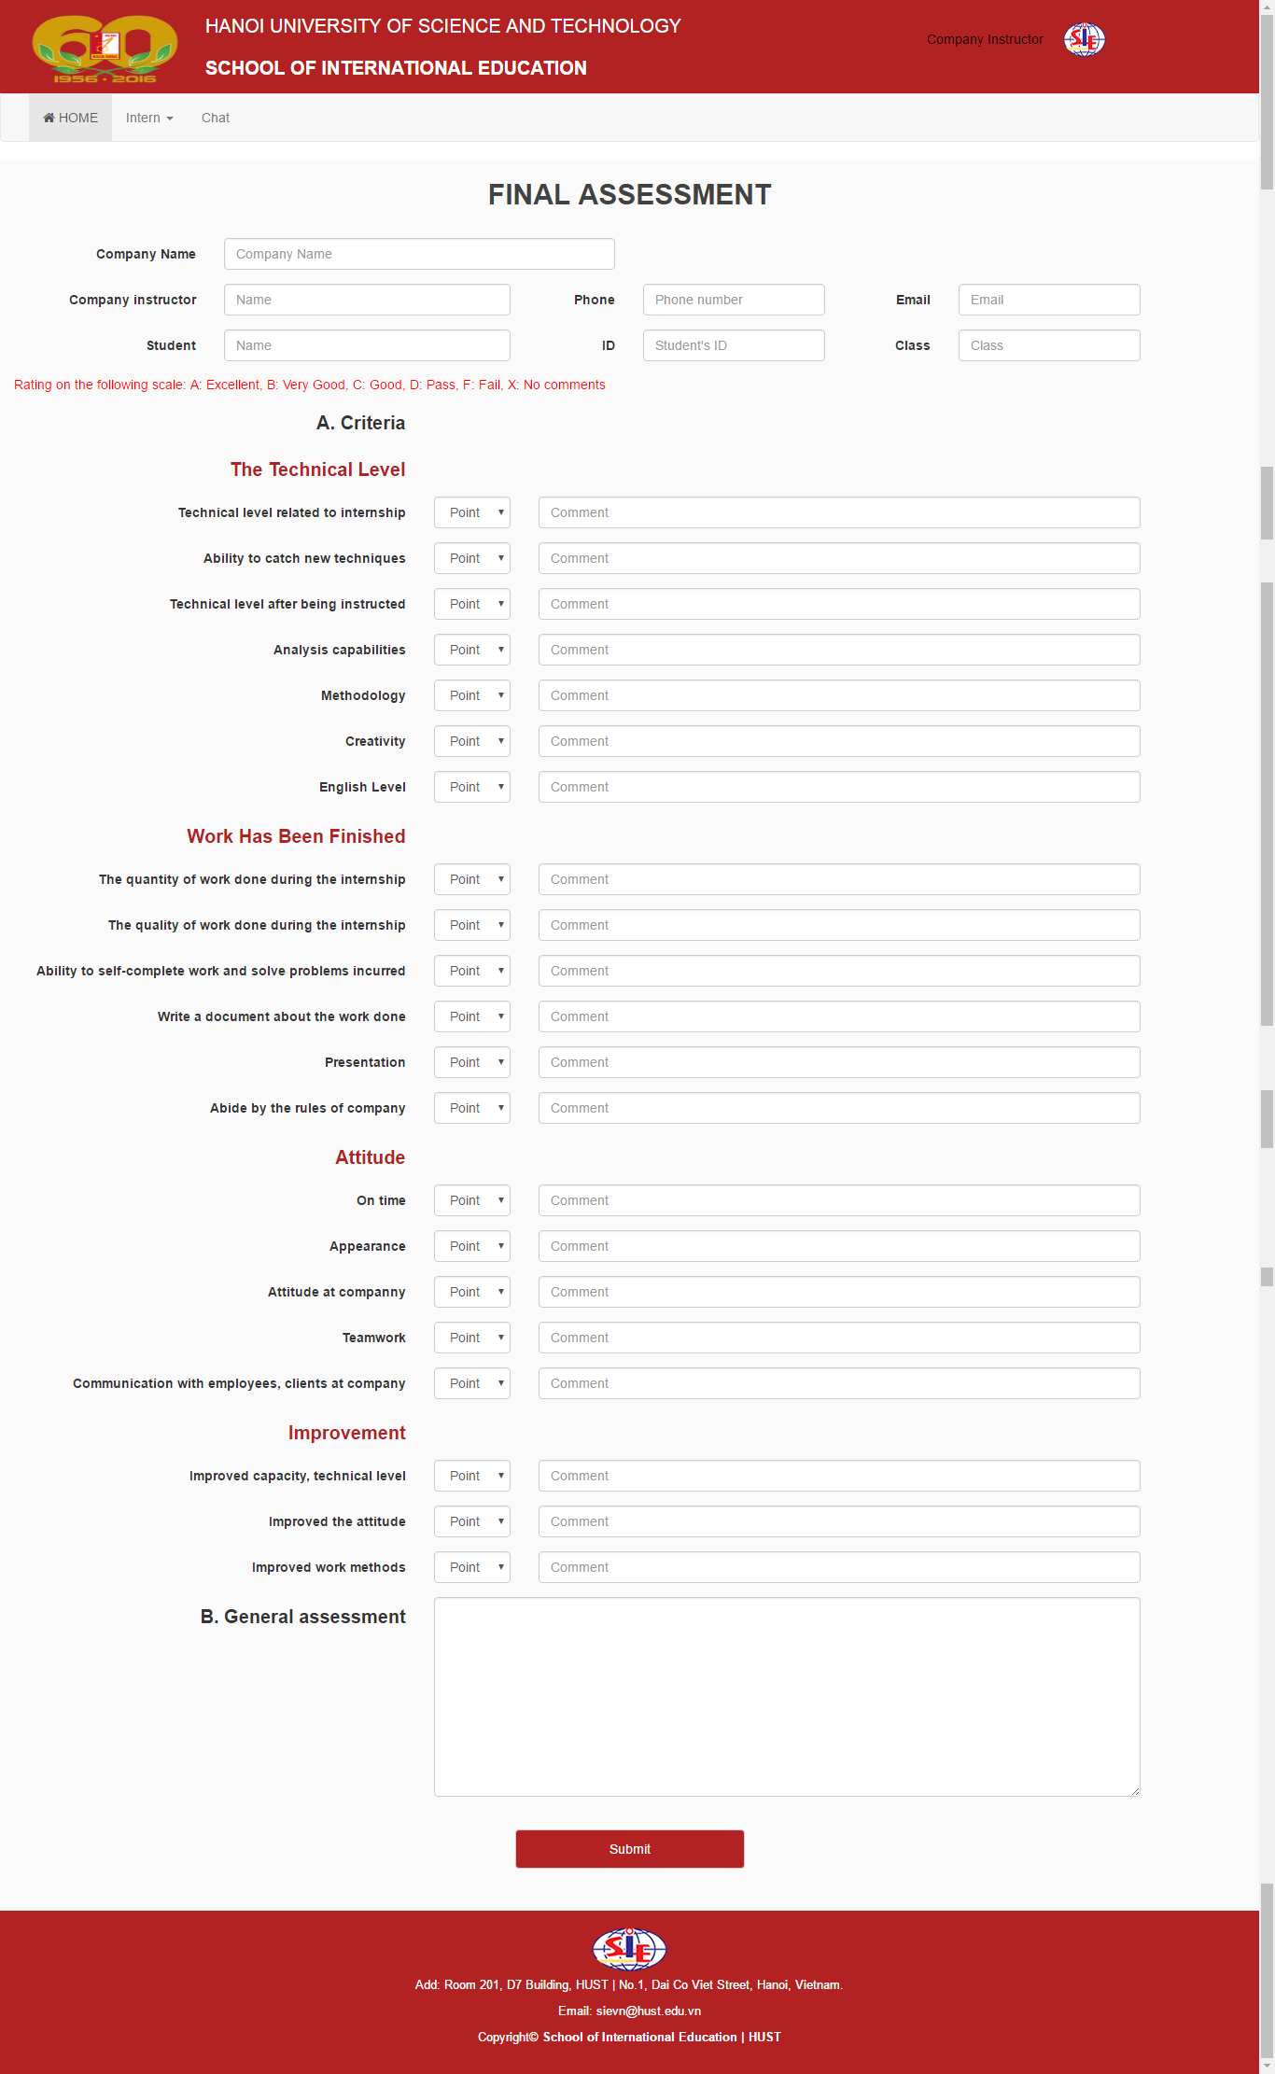

*Admin:*

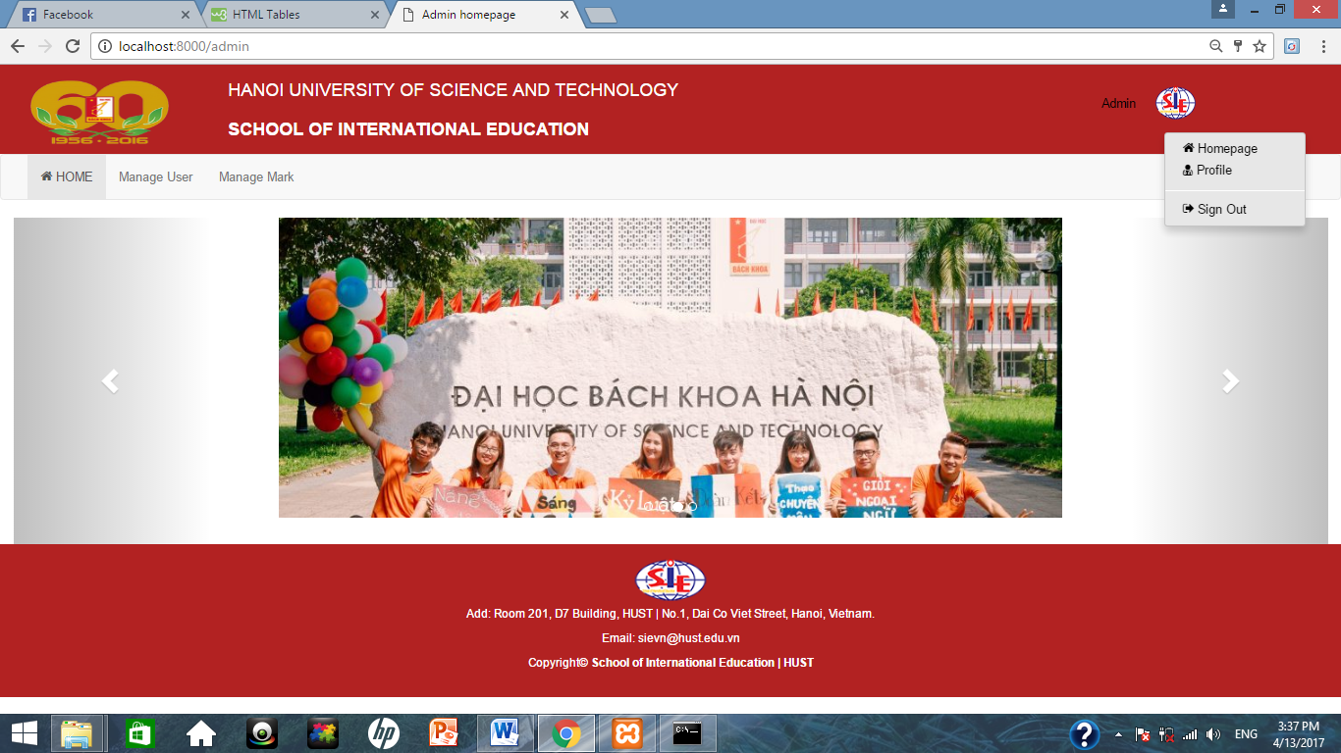

### Site flow

*Student:*

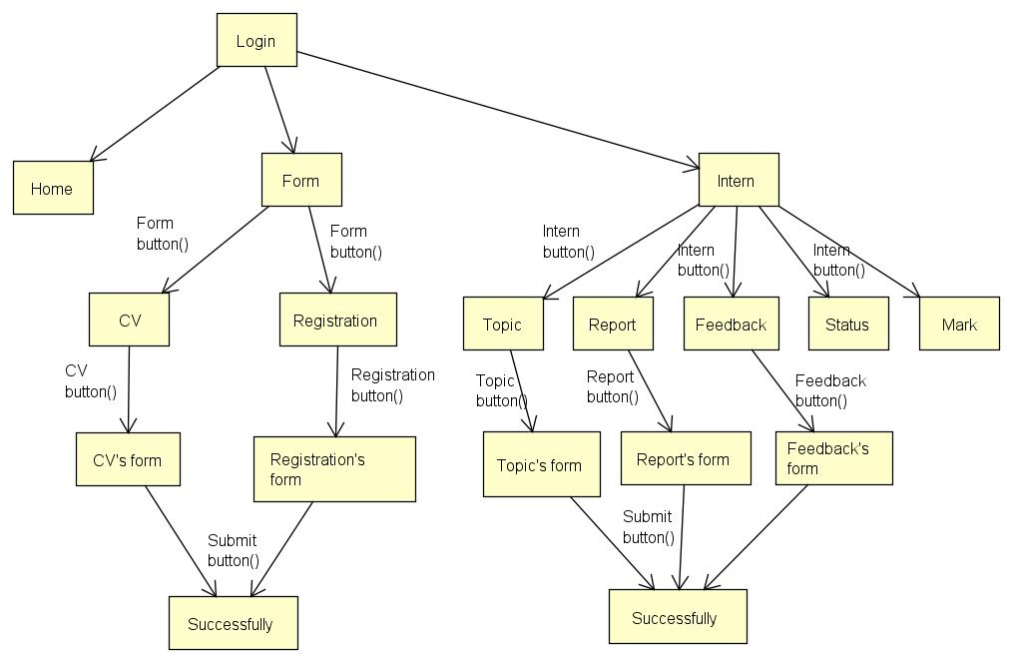

*College instructor:*

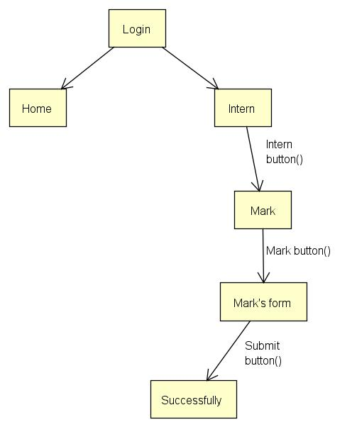

*College internship manager:*

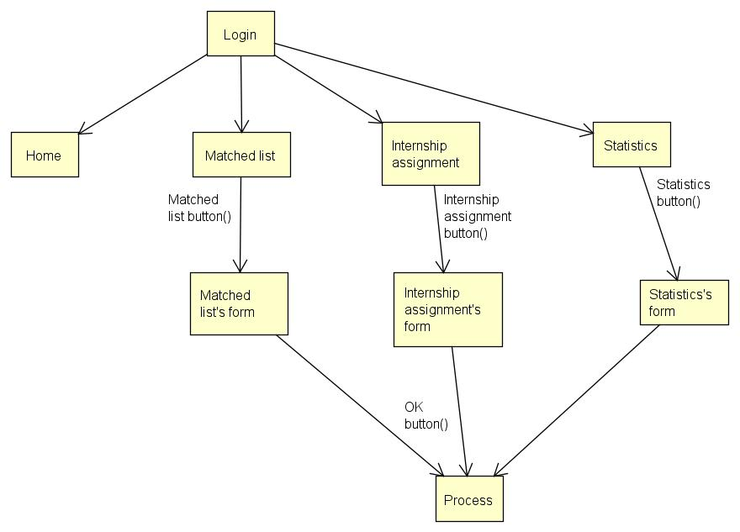

*Company representative:*

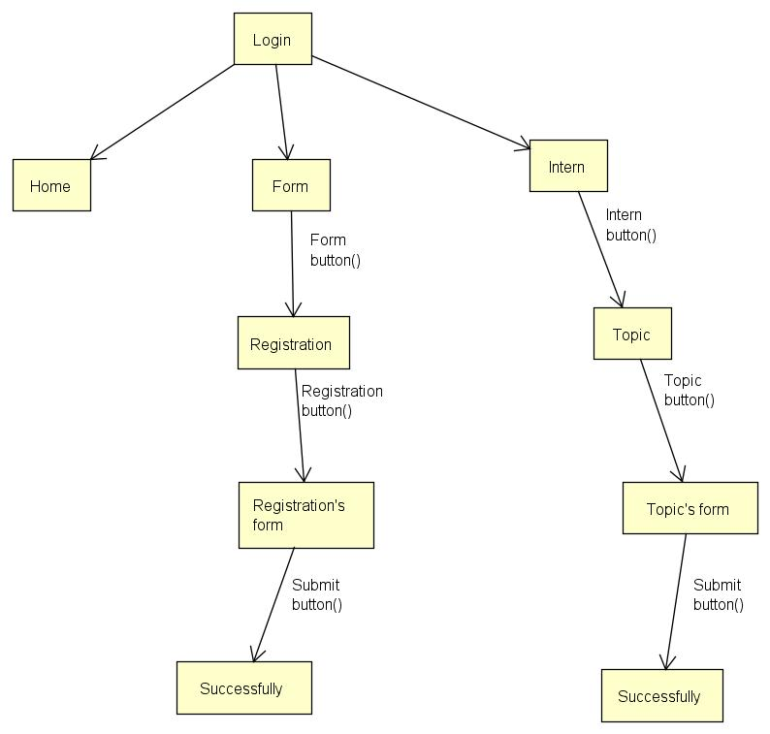

*Company instructor:*

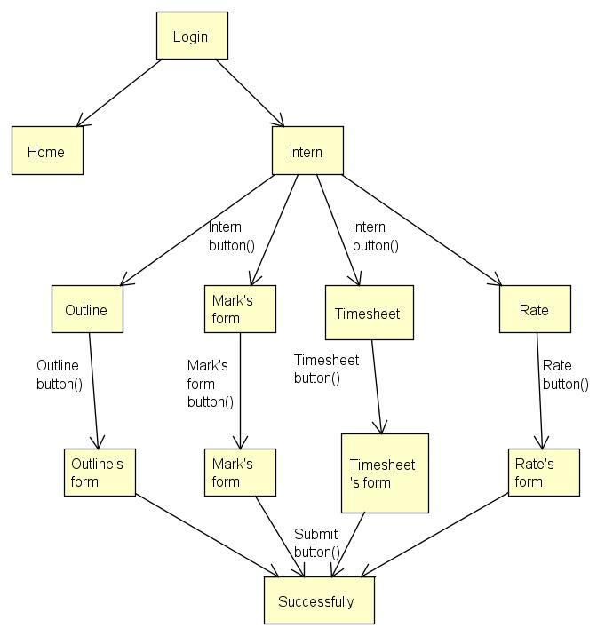

### Interaction support

#### Response message

<Design notification/response interface of the system>

#### Fault Tolerance

<Design error and error type notification and fault tolerance>

#### Help

<Design help and help effect>

#### Manual

<Design manual/instructions, example: FAQ>

# CHAPTER 2. IMPLEMENTATION AND SYSTEM TEST

## Programming Platform

### Programming Language

Main programming lannguage: PHP, Javascript, HTML/CSS.

### IDE / Programming Framework

Framework Laravel, Bootstrap.

### Libraries

* "laravel/framework": "5.4.*",
* "laravel/tinker": "~1.0",
* "laravelcollective/html": "^5.4.0"

## Program Structure

<Vẽ và giới thiệu cấu trúc phân cấp của chương trình theo mô hình MVC, mối quan hệ giữa các module/component trong chương trình. Chỉ rõ cách tiếp cận sinh viên áp dụng để phân rã chương trình: theo chức năng, theo Algorithm hay theo dữ liệu. Chỉ rõ nguyên tắc gom nhóm các thành phần trong chương trình tại mỗi mức phân cấp>

<với mỗi module/component, chú thích rõ phần nào tự code, phần nào tái sử dụng>

<Chỉ rõ chương trình tái sử dụng bao nhiêu phần trăm, tự xây mới bao nhiêu phần trăm – thiếu thông tin này không được tính điểm>

## System Test

### Test platform

<Require Implementation on hosting only, not on localhost>

### Testing techniques

<List 5 – 10 testing techniques that are used. kỹ thuật kiểm thử đã sử dụng. Với mỗi kỹ thuật:

Nêu rõ mục tiêu kiểm thử, xây dựng kịch bản kiểm thử (dữ liệu vào, dữ liệu trung gian mong muốn qua từng bước thực hiện, dữ liệu ra). Mô tả cách áp dụng, đối tượng áp dụng (hàm, câu lệnh hay chương trình) và phạm vi áp dụng. >

## Results

|  |  |  |
| --- | --- | --- |
|  | Functions | Result |
|  | Login | Done successfully |
|  | Logout | Done successfully |
|  | Edit profile | Done successfully, has been saved to the database |
| Student | Edit CV | Done successfully, has been saved to the database |
| View topic list | Done successfully, can see the list of topic after censored |
| Fill in internship registration for Student | Done successfully, has been saved to the database |
| Feedback | Done successfully |
| Submit report | Done successfully, can upload file |
| View internship’s status | Done successfully |
| View internship’s mark | Done successfully |
| College internship manager | Matched information | Done |
| Assign schedule | Done |
| Statisticing | Done |
| Check topic list | Done successfully |
| College instructor | Mark student | Done |
| Company representative | Fill in internship registration for Company | Done successfully |
| Publish topic | Done successfully |
| Company instructor | Submit outline | Done successfully |
| Fill in mark’s form | Done successfully |
| Rate | Done successfully |
| Submit timesheet | Done successfully |
| Admin | Manage user | Done |
| Manage mark | Done |

## System Documentation

### Internal Documentation

<Describe method of compiling the system from source files and libraries>

### External Documentation

<Describe method of using functions of the system through the interface>

CONCLUSION AND FUTURE WORK

*Through the process of learning, with the efforts of the members, we have completed project on time and achieved the following results:*

* *Understand the process, internship management.*
* *Analyzes the process and functions of the system through UML diagrams and builds the database.*
* *The program response a number of user requirements:*
* *The program has friendly interface, easy to use.*
* *The program response the functions of the internship management system.*

*However, there are still some limitations as there is no search function*

REFERENCE

[1] Internet.

APPENDIX

*HOW TO USE:*

Go to and log in with each account as follows.

|  |  |
| --- | --- |
| **Account** | **Password** |
| [admin@gmail.com](mailto:admin@gmail.com) | 123456 |
| [student@gmail.com](mailto:student@gmail.com) | 1234567 |
| [collegeintershipmanager@gmail.com](mailto:collegeintershipmanager@gmail.com) | 123456 |
| [collegeinstructor@gmail.com](mailto:collegeinstructor@gmail.com) | 1234565 |
| [companyrepresentative@gmail.com](mailto:companyrepresentative@gmail.com) | 123456 |
| [companyinstructor@gmail.com](mailto:companyinstructor@gmail.com) | 123456 |

*Student:* At menubar, you can:

* Fill out CV’s form.
* Fill out Registration’s form.
* View topic list.
* Feedback about internship.
* Report about internship.
* View intern mark.
* View intern status.

*College Internship Manager:* At menubar, you can:

* Censor topic.
* Matched information.
* Assign internship’s schedule.
* Statistics student finished/ unfinished.

*College instructor:* At menubar, you can:

* Mark student.

*Company Representative:* At menubar, you can:

* Fill out Registration’s form.
* Publish topic list.

*Company Instructor:* At menubar, you can:

* Upload detail outline’s file.
* Fill out Mark’s form.
* Upload Timesheet’s file.
* Fill out Rate’s form.

*Admin:* At menubar, you can:

* Manage user.
* Manage mark.

You can edit each actor profile and log out.